**Data Science Job Readiness**

**United States Airlines Analysis**

**SQL & Tableau Task**

1. Determine the number of flights that are delayed on various days of the week.

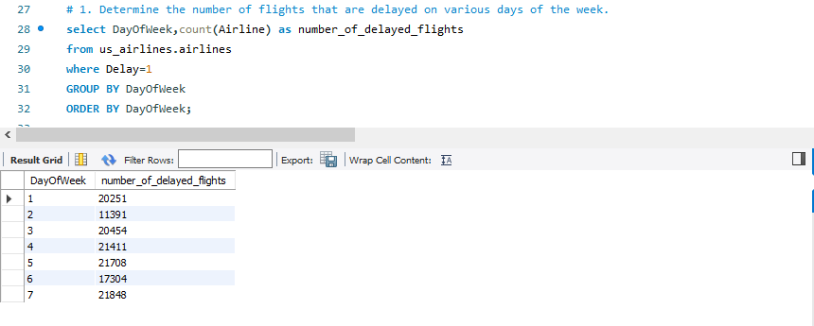

1. Find the number of delayed flights for different airlines.

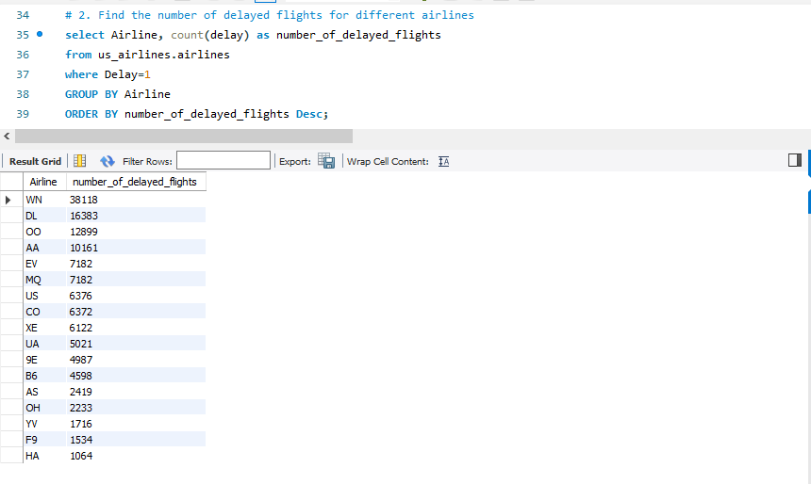

1. Determine how many delayed flights land at airports with at least 10 runways.

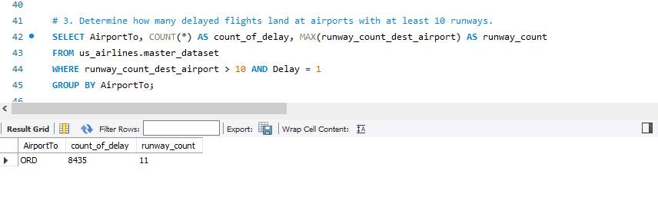

1. Compare the number of delayed flights at airports higher than average elevation and those that are lower than average elevation for both source and destination airports.

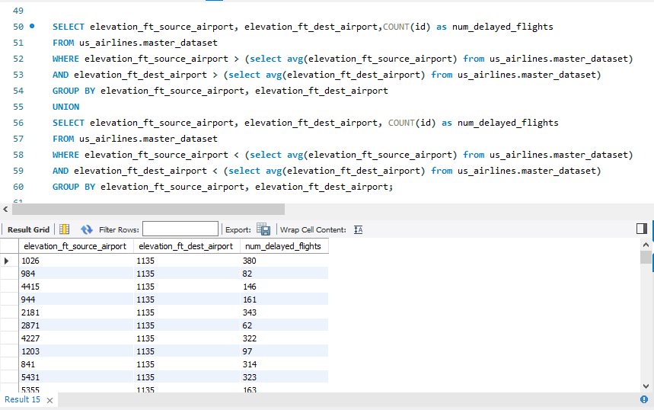

**Tableau Task**

